Hajra 12/5/2019

Observations and Playtester Comments

# In-Game Observations

[Your thoughts as you watch the testers play]

* Controls are smooth
* Maybe need to zoom out a little more to see the town

# In-Game Questions

Why did you make that choice? (go into the house)

* I have played exploration games before so I knew I should be able to go into the houses or else there would be nothing else to do

Does that rule seem confusing?

* NA

What did you think that would do? (go into the house)

* Bring up a new view

What is confusing for you?

* The storyline is not there so I did not know the objective of the game

# Postgame Questions

[Questions you ask the testers as they have played]

Did you think the graveyard meant something?

* Yes, but was not sure what

Did you like going into the houses?

* Yes, they added to the game feel

## General Questions

What was your ﬁrst impression?

How did that impression change as you played?

Was there anything you found frustrating?

Did the game drag at any point?

Were there particular aspects that you found satisfying?

What was the most exciting moment in the game?

Did the game feel too long, too short, or just about right?

## Formal Elements

Describe the objective of the game.

* Explore the game?

Was the objective clear at all times?

* no

What types of choices did you make during the game?

* What house to go into, who to talk to

What was the most important decision you made?

* NA

What was your strategy for winning?

* Walk around and explore the game

Did you ﬁnd any loopholes in the system?

* You cannot interact with people yet

How would you describe the conﬂict?

* NA

In what way did you interact with other players?

* There are NPCs but no other players

Do you prefer to play alone or with human opponents?

* Either way, but usually play exploration games so alone

What elements do you think could be improved?

* Add the storyline

## Dramatic Elements

Was the game’s premise appealing to you?

* Yes I LOVE explorer games

Did the story enhance or detract from the game?

* NA

As you played, did the story evolve with the game?

* NA

Is this game appropriate for the target audience?

* Yes, teens would love this for exploring

On a piece of paper, graph your emotional involvement over the course of the game.

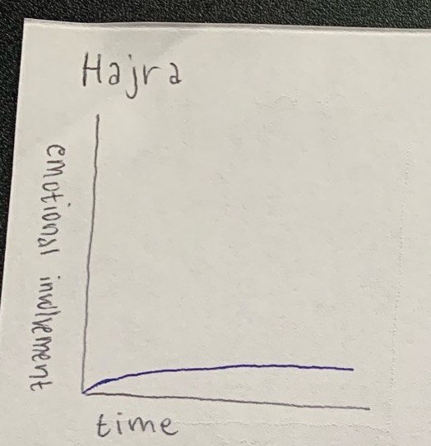

Did you feel a sense of dramatic climax as the game progressed?

* NA no storyline

How would you make the story and game work better as a whole?

* Add in the story and make sure I would understand what is going on in the beginning

## Procedures, rules, interface, and controls

Were the procedures and rules easy to understand?

* Just walk around in bounds

How did the controls feel? Did they make sense?

* Yes, just moving around with the arrow keys; pretty self-explanatory

Could you ﬁnd the information you needed on the interface?

* Yes, the bars were there

Was there anything about the interface you would change?

* No, everything seems to be there

Did anything feel clunky, awkward, or confusing?

* no

Are there any controls or interface features you would like to see added?

* Everything seems to be there, so I believe everything is good

## End of Session

Overall, how would you describe this game’s appeal?

Would you purchase this game?

* no

What elements of the game have reacted you?

* The bunny was very cute; I also enjoyed the scenery of the game

What was missing from the game?

* The storyline

If you could change just one thing, what would it be?

* Storyline needs to be included

Who do you think is the target audience for this game?

* Teen/college students

If you were to give this game as a gift, who would you give it to?

* My nephew

# Revision Ideas

[Ideas you have for improving the game]

* Maybe have like a little map of the town on the screen?
* Add arrows for houses
* More interactions and popups needed